Information Brief

98-2

Are America's Students Taking More Science and Mathematics Course Work?
The National Educational Goals Panel, created in 1990 to monitor educational progress and report to the American Public, has stated that over the past several decades, performance in mathematics and science has been "extremely weak." The most recent Goals Panel report, based on 1995 data, noted some improvement, but stressed that more could be done to improve the mathematics and science skills of all students.
Historically, females, African Americans, Native Americans, and Hispanics have been underrepresented in courses, programs, and careers requiring mathematics and science. Their performance in these subjects has also been lower than that of other groups.
To provide a look at current trends, ACT has studied the mathematics and science course taking patterns of college-bound students from 1987 through 1997 (see ACT Research Report No. 97-8). We found that the percentages of ACT-tested high school students taking upper-level mathematics or science courses have increased for all racial/ethnic and gender groups. Further, females and historically underrepresented minorities have shown improved achievement, as measured by their ACT Mathematics and Composite scores.

What evidence suggests high school students are making progress in mathematics and science?
In 1997, more students were taking or planning to take each of six high school mathematics and science courses (algebra II, geometry, trigonometry, calculus, chemistry, and physics). The increases varied by course, ranging from a slight increase in trigonometry (43% to 48%) to a large increase in chemistry (67% to 81%) (see Figure 1).
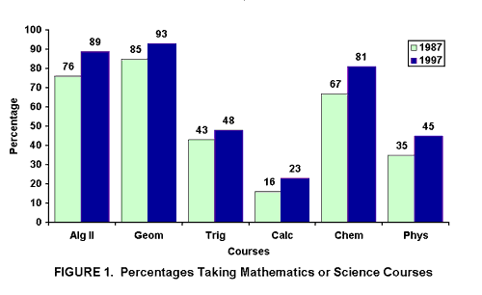
Increases by gender. Increases between 1987 and 1997 in the percentages of students taking mathematics and science courses were greater for females. The percentage of females taking algebra II increased from 74% to 89%; the percentage of males, from 78% to 88% (see Table 1). Similar patterns occurred for the other courses.
Table 1. Percentages Taking Mathematics or Science Courses by Gender
Course | Gender | 1987  % | 1997  % | Increase  In %
Algebra II | Male  Female | 78  74 | 88  89 | 10  15
Geometry | Male  Female | 87  84 | 92  93 | 05  09
Trigonometry | Male  Female | 49  39 | 49  46 | 00  07
Calculus | Male  Female | 20  12 | 26  21 | 06  09
Chemistry | Male  Female | 69  64 | 79  82 | 10  18
Physics | Male  Female | 44  27 | 50  41 | 06  14
Increases by racial/ethnic group. Relatively large increases in mathematics and science course taking were found for historically underrepresented minority groups. For example, the percentages of students taking Algebra II increased by 23 points for Native Americans (59% to 82%) and 16 points for Mexican Americans (69% to 85%) and African Americans (67% to 83%) (see Table 2). Increases for other racial/ethnic groups, though positive in most instances, were smaller.
Table 2. Percentages of Three Racial/Ethnic Groups
Taking Mathematics or Science Courses
Native Americans
Course | 1987 % | 1997 % | Increase in %
Algebra II | 59 | 82 | 23
Geometry | 65 | 85 | 20
Trigonometry | 28 | 36 | 08
Calculus | 09 | 15 | 06
Chemistry | 49 | 69 | 20
Physics | 25 | 34 | 09
Mexican Americans
Algebra II | 69 | 85 | 16
Geometry | 78 | 94 | 16
Trigonometry | 33 | 43 | 10
Calculus | 13 | 21 | 08
Chemistry | 57 | 78 | 21
Physics | 27 | 41 | 14
African Americans
Algebra II | 67 | 83 | 16
Geometry | 76 | 91 | 15
Trigonometry | 37 | 40 | 03
Calculus | 13 | 17 | 04
Chemistry | 59 | 78 | 19
Physics | 29 | 37 | 08
Increases in test scores. Between 1987 and 1997, the national average ACT Composite score increased by 0.3 points and the average ACT Mathematics score increased by 0.6 points (on a scale of 1 to 36). As shown in Figure 2, the average ACT Composite score for females nationwide increased by 0.7 points, and their average ACT Mathematics score increased by 0.9 points. These scores also increased substantially for Native Americans, Mexican Americans, and African Americans, compared to other racial/ethnic groups (see Figure 2). We did not include Science Reasoning test scores in the study; they have been available only since 1989.
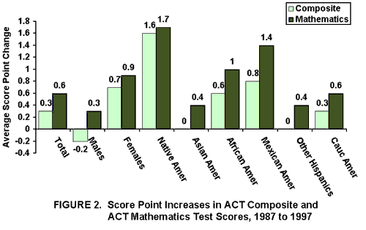

Discussion
How can we account for such increases? Students, particularly females and underrepresented minorities, are taking more mathematics and science courses. States have been setting more challenging standards for students. The curriculum is receiving closer scrutiny with respect to subject matter standards, and efforts are being made to strengthen teachers' knowledge of mathematics and science and their instructional skill in these subjects. Schools are requiring more of such courses, and college requirements are becoming more rigorous. The message about the importance of these subjects is getting out, and those who were behind in mathematics and science course taking are responding to it.
The bottom line is that though the U.S. is far from the top in mathematics and science achievement worldwide, the National Education Goals Panel (1997) believes we can be first. These results suggest that U.S. achievement can be improved, at least among college-bound students. As the end of the millennium approaches, we are likely to see a continuing upward trend.
ACT welcomes your comments on this Information Brief, written by Gail McLure. Please send them to ACT_Information_Briefs@act.org or call 319/337-1077.

